Lab Assignment 1.3-1: Using GitHub Copilot for Python Programming
Name: Suvikhyath Thirunahari
Roll No: 2503B05202
Course: AI Assisted Problem Solving Using Python
Date: 02-11-2025
Objective
The objective of this lab is to learn how to use GitHub Copilot to generate, review, and test Python functions. This includes setting up the Copilot extension in Visual Studio Code, generating code using comments as prompts, testing Copilot’s output, and reflecting on the quality and accuracy of the generated solutions.

Task 1: Installation and Configuration of GitHub Copilot
Steps followed:
- Opened Visual Studio Code and navigated to the Extensions tab (Ctrl+Shift+X).
- Searched for 'GitHub Copilot' and installed the extension.
- Signed in with a GitHub account and activated Copilot subscription.
- Enabled inline suggestions under VS Code settings.
- Tested Copilot by typing a comment and observing an inline code suggestion.

[Step 1: Installation]
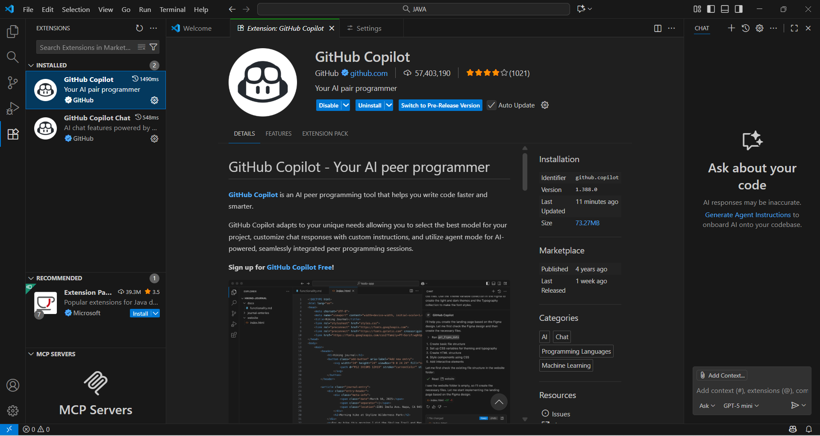

[Step 2: Sign-in confirmation]

[Step 3: Copilot suggestion]
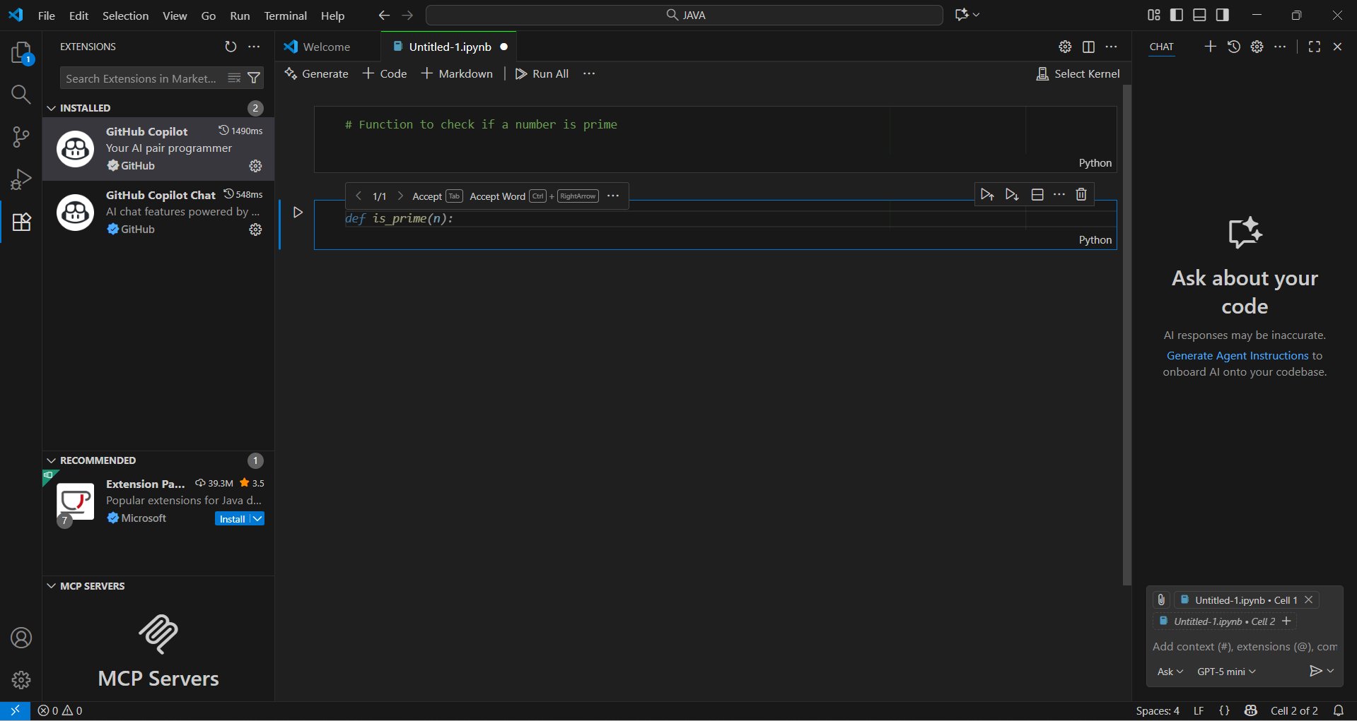

Task 2: Prime Number Function using Copilot
Prompt used: 'Function to check if a number is prime'
Copilot suggested the following function:
def is_prime(n: int) -> bool:
if n <= 1:
return False
if n <= 3:
return True
if n % 2 == 0 or n % 3 == 0:
return False
i = 5
while i * i <= n:
if n % i == 0 or n % (i + 2) == 0:
return False
i += 6
return True
Test cases executed:
Input: [0, 1, 2, 3, 4, 16, 17, 19, 25, 97]
Output:
0 False
1 False
2 True
3 True
4 False
16 False
17 True
19 True
25 False
97 True
Copilot suggestion:
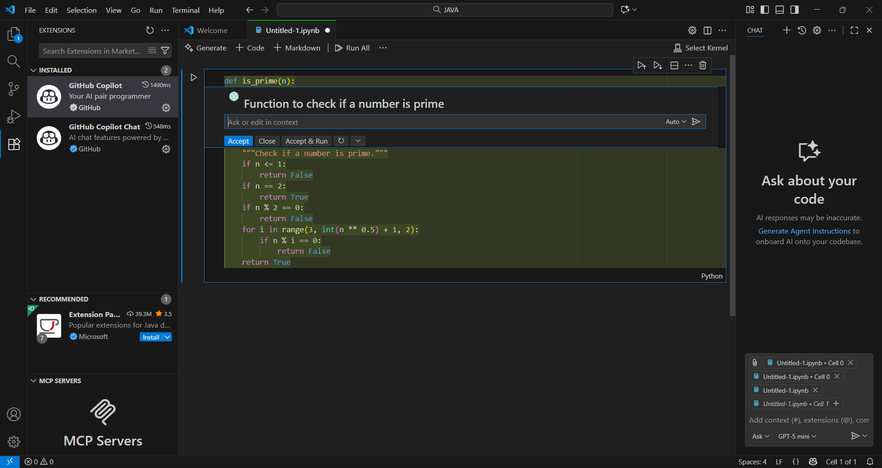
Terminal output:
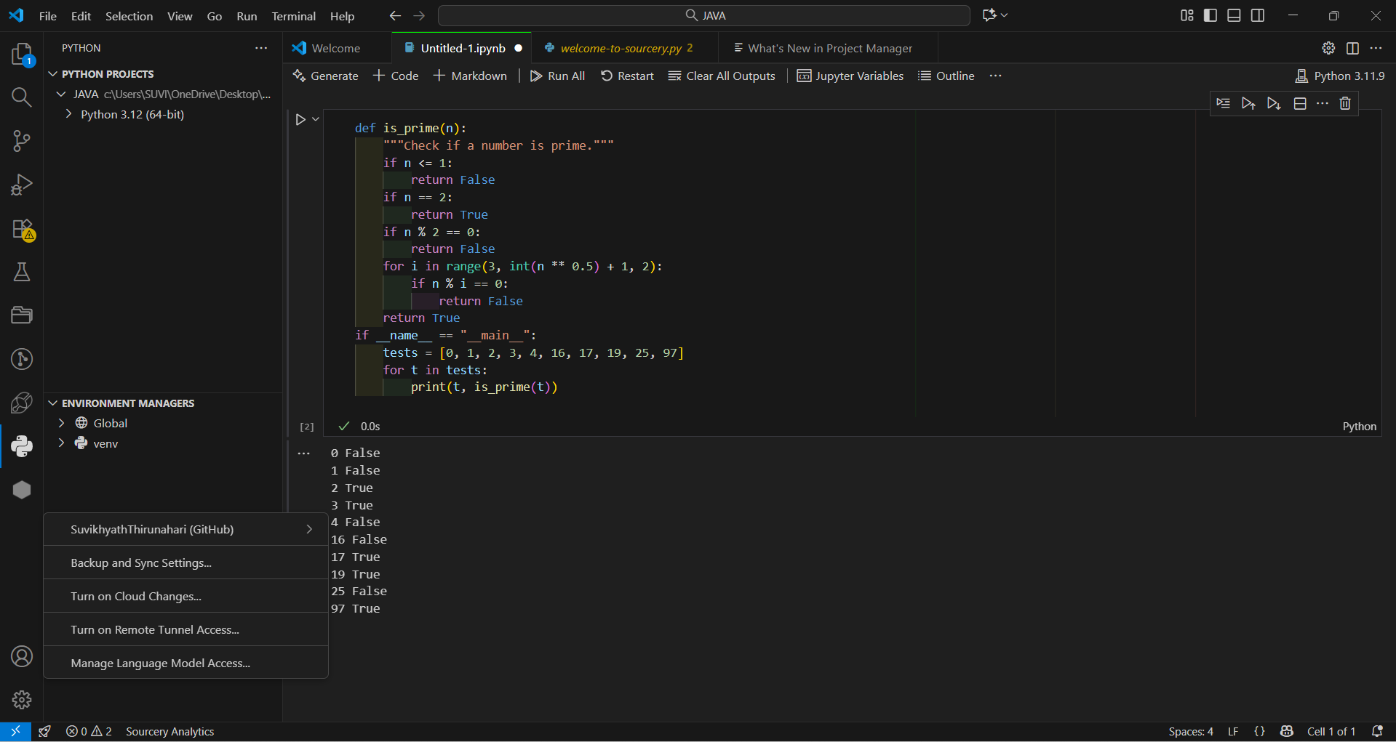

Task 3: Reverse a String
Prompt used: 'Function to reverse a string'
Copilot generated:
def reverse_string(s: str) -> str:
return s[::-1]
Test case: reverse_string('hello') → 'olleh'
Copilot suggestion:
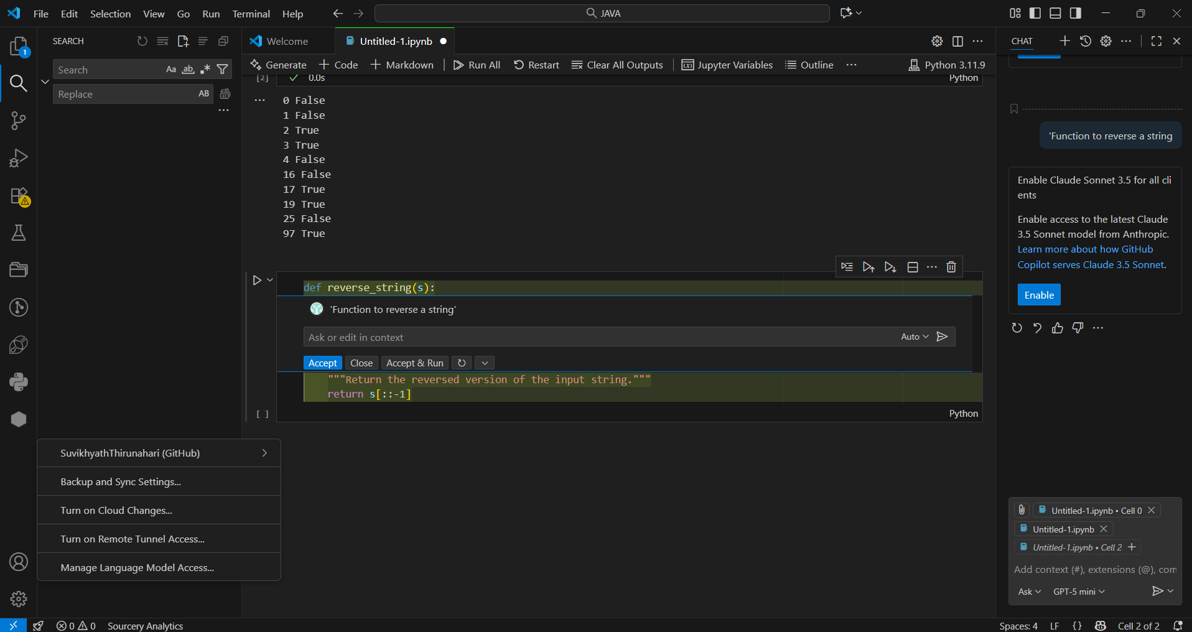
Terminal output:
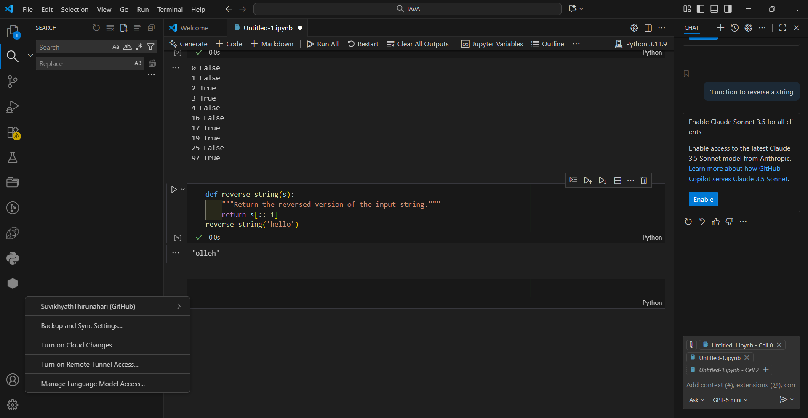

Task 4: Recursive and Iterative Factorial Functions
Prompts used:
- 'Recursive factorial function'
- 'Iterative factorial function'
Copilot generated or completed the following:
def factorial_recursive(n: int) -> int:
if n < 0:
raise ValueError("n must be >= 0")
if n == 0:
return 1
return n * factorial_recursive(n - 1)
def factorial_iterative(n: int) -> int:
if n < 0:
raise ValueError("n must be >= 0")
result = 1
for i in range(2, n + 1):
result *= i
return result
Test Results:
Input range: 0–5
Output matches for both recursive and iterative implementations.
Screenshots:
Recursive suggestion:
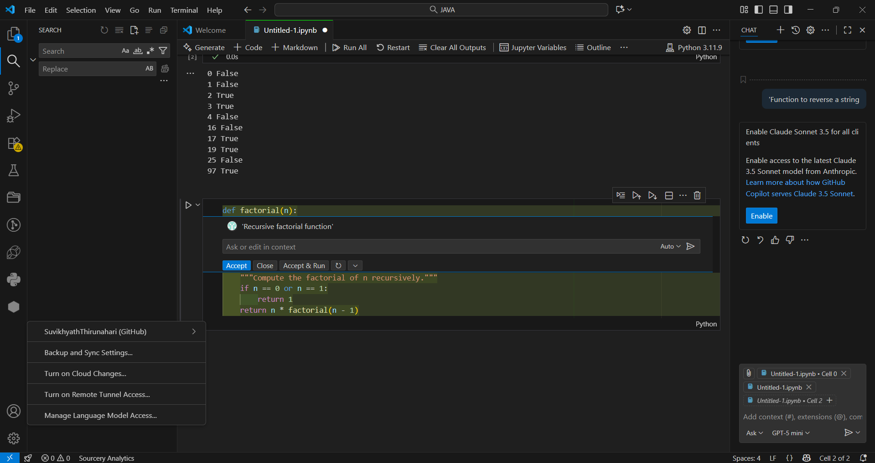
Iterative suggestion:
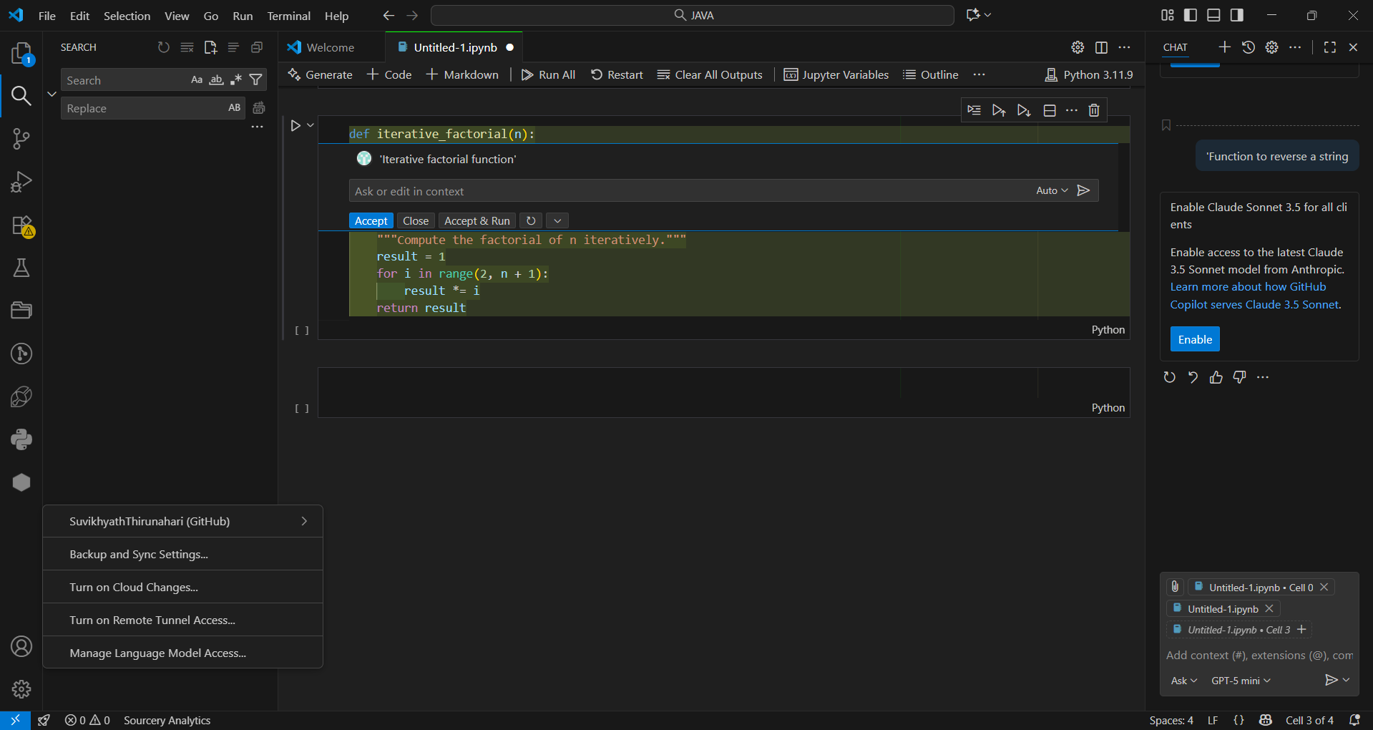
Output results:
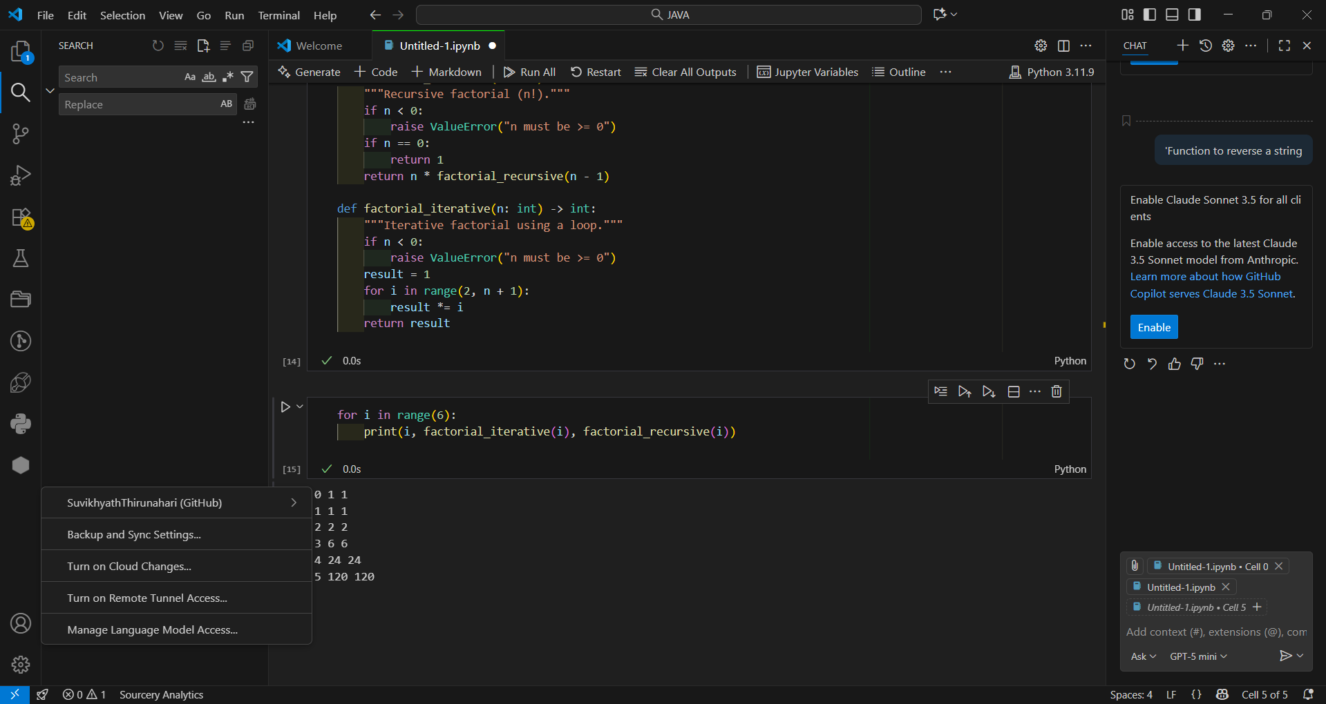
Observation: The recursive method is elegant but less memory efficient for large n. The iterative version is faster and safer for high values.

Task 5: Finding the Largest Number in a List
Prompt used: 'Function to return the largest number in a list'
Copilot suggestion:
def max_in_list(nums: list) -> int:
if not nums:
raise ValueError("List is empty")
max_val = nums[0]
for n in nums:
if n > max_val:
max_val = n
return max_val
Test case: max_in_list([3, 7, 2, 10, 6]) → 10
Assessment: Copilot’s solution is correct and clear. Efficiency can be improved by using Python’s built-in max() function.
Screenshots:
Copilot suggestion:
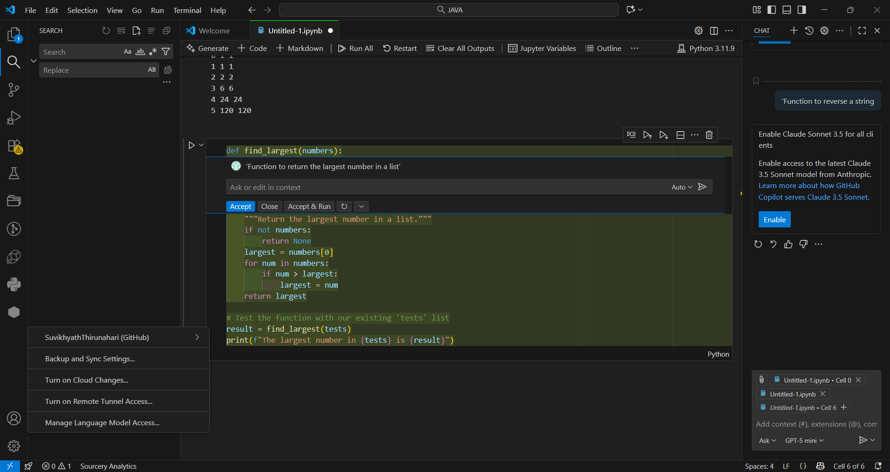
Output:
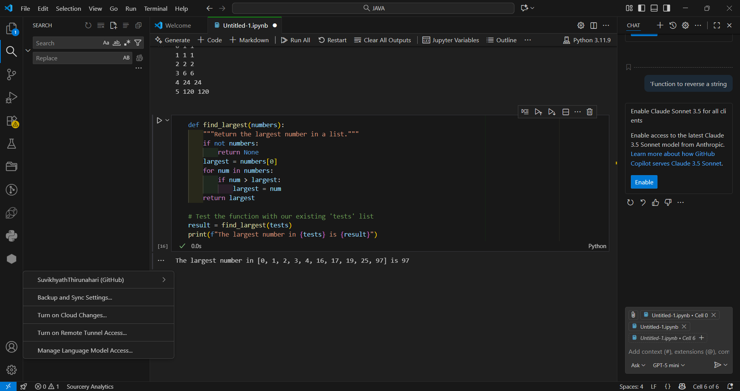

Conclusion
Through this lab, GitHub Copilot proved to be an effective AI assistant for generating correct and efficient Python functions. It helped reduce time spent on syntax and logic details while allowing focus on testing and understanding program behavior. However, user oversight remains crucial to verify correctness and optimize code quality.

